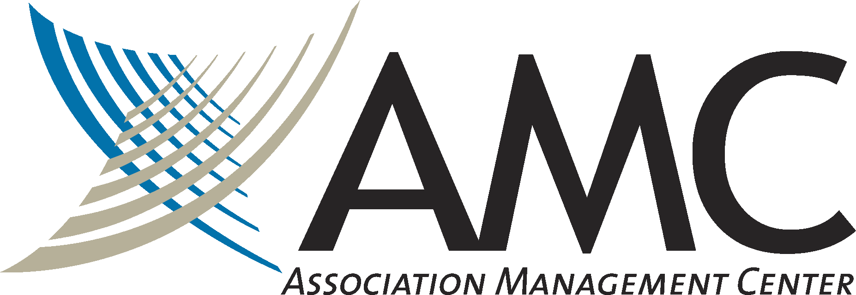

Association Management Center seeks an Education Manager to join our team. The Education Manager is responsible for developing, planning, and executing continuing education and professional programming needs for two healthcare organizations, Academy of Breastfeeding Medicine and International Transplant Nurses Association. This role will be a member of a small team and will play an instrumental role in helping these clients succeed. Each client has approximately 1000 members.

If you are passionate about your impact, believe working as one team equals success, and are committed to growth and development, this could be a great career opportunity for you.

This role is based in Chicago and is hybrid - one day per week onsite. Out-of-state candidates may also be considered, depending on location.

Responsibilities

- Develop, coordinate, and execute new and existing programs and activities, primarily conference and courses, but may include other programs and products as needs arise.
- Contribute to both team and volunteer committee planning processes for educational activities by gathering, analyzing, and interpreting information to help identify educational needs of members of the profession.
- Develop, compile, and analyze evaluation reports for educational activities to determine effectiveness, outcomes measurements, and future needs.
- Keep abreast of current CE accreditation standards, policies, and procedures and how they apply to planning CE activities.
- Ensure that required components of education programs meet the accreditation standards and correspond to the continuing education mission of the organization.
- Prepare and submit annual CE reports to accreditation providers.
- Provide leadership and support to program, CE, and other assigned committees and task forces regarding content development, faculty recruitment and other course logistics.
- Build relationships with thought leaders within the specialties to develop a network of dependable content experts.
- Develop comprehensive project timelines for all activities and manage project plans to meet deadlines and ensure successful programs.
- Manage administrative activities related to educational programs including creating and monitoring budgets, conference call and other meeting agendas, preparing action notes or minutes.
- Manage vendor relationships for educational programming needs including negotiating agreements, quality delivery of services, monitoring expenses and invoices.
- Maintain up-to-date project reports including project status, expenditures, project planning timelines and final activity reports.
- Collaborate with staff responsible for obtaining educational sponsorships and grant funding to ensure compliance with accrediting bodies.
- Develop and manage timely and professional communication including written, electronic, and oral communication, with staff team members, SMEs, committees, and task force members.
- Assist with technical training for faculty, SMEs, and volunteers, as needed.
- Create program schedules, outlines, handout materials, presentation materials, online surveys, and evaluation materials for assigned programs.
- Develop program descriptions suitable for internal and external communication and review draft promotional brochures and other materials prior to final printing to ensure accuracy and completeness.
- Serves as the first line of contact, service, and support to members with questions about educational programs and resources.
- Perform other duties as assigned

Qualifications

- Bachelor’s degree.
- 4 years progressive professional responsibility for management and administration of education programs, including curriculum development and demonstrated knowledge of the continuing education essentials and standards.
- Experience and knowledge of relevant CE policies and requirements, experience with nursing and physician accreditation a plus.
- Knowledge of contemporary e-learning technologies.
- Excellent interpersonal, verbal, and written communication skills.
- Excellent proofreader.
- Ability to effectively collaborate internally and externally to achieve goals of each organization.
- Ability to manage multiple tasks simultaneously and ensure timely and accurate results.
- Organized, resourceful, takes initiative.
- Strong customer orientation.
- Strong collaborator.
- Computer proficiency.
- Ability to travel out of state and overnight up to 3 times per year. Potential for international travel on occasion.
- Commitment to company values.

Association Management Center is an equal opportunity employer. We are committed to building a diverse team in which all employees are welcomed, valued and respected for their individual strengths, perspectives, and contributions.

Disclaimer
The statements herein are intended to describe the general nature and level of work being performed by the employee in this position. They are not intended to be construed as an exhaustive list of all responsibilities, duties, and skills required of a person in this position.

How to Apply:
Qualified candidates can click here to apply directly, or forward a resume and salary requirements to Summar Jonas, Talent Acquisition Manager at sjonas@connect2amc.com

